**The Battle of Neighborhoods**

What’s this about?

Now that we have been equipped with the skills and the tools to use location data to explore a geographical location, over the course of two weeks in the Coursera Course “Applied Data Science Capstone Project”, we have the opportunity to be as creative as we want and come up with an idea to leverage the Foursquare location data to explore or compare neighborhoods or cities of our choice or to come up with a problem that we can use the Foursquare location data to solve. Based on that I chose to solve accommodation the problem of a traveler who travels to Toronto for the first time and knows nothing about it.

More specifically, let's say we want to travel to Toronto. It would be very difficult to decide the neighborhood in which it would be better for as to stay during our holidays. But with this report and analysis of the data taken from Foursquare API it is much easier to learn the basics for each neighborhood and make a decision.

Data collected:

Using Foursquare API we will retrieve the information needed to do our report and end up to a conclusion:

* Museums
* Monuments
* Restaurants
* Coffee shops
* Bars
* Shopping Centers
* Theaters

Data Visualization:

After collecting all that information for Toronto we will visualize them using folium in a map with different colors for each category so that anyone will be able to see what's where and decide where they prefer to stay during their vacation according to their preferences in amusement.

Data frames:

Using the pandas library, we collect the information about Toronto’s neighborhoods which we will use later for the analysis.

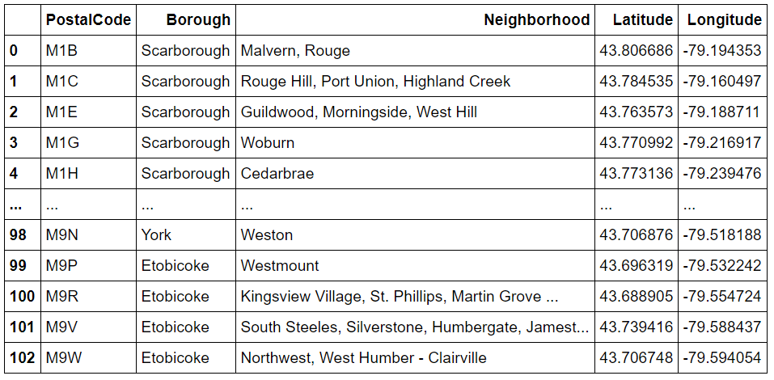

Using Foursquare API we create a get request and we take a JSON which we transform to a data frame of name , latitude and longitude of the places returned in each case.

Data frame of Coffee Shops

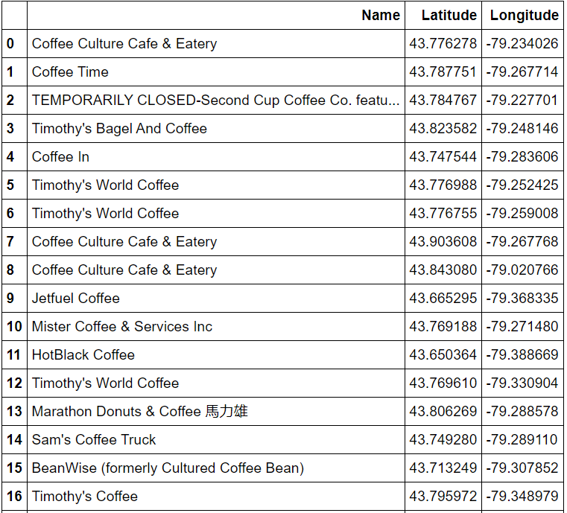

Data frame of Museums

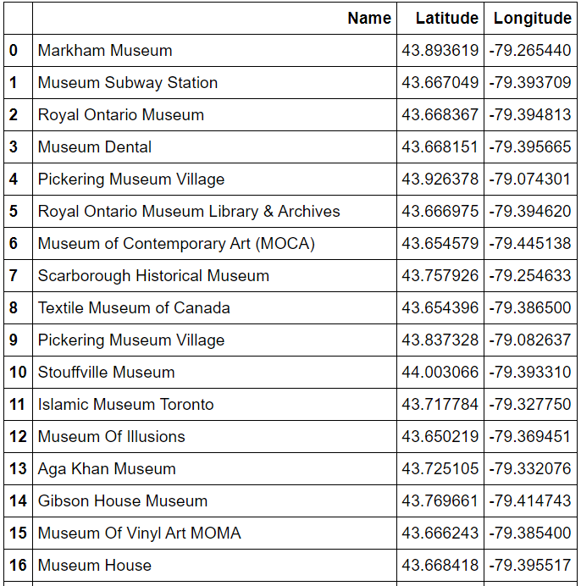

Data frame of Monuments

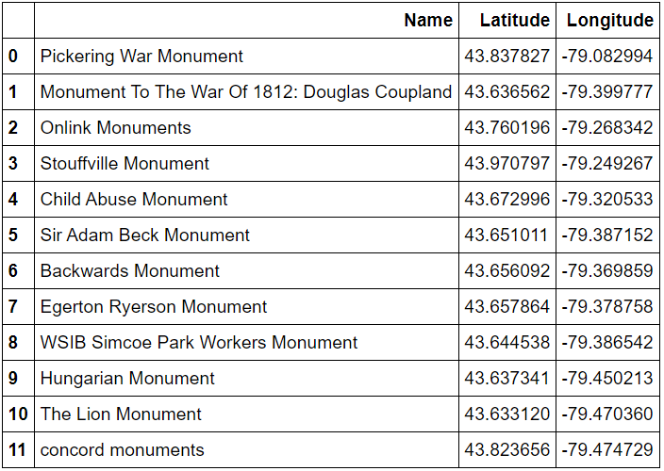

Data frame of Restaurants

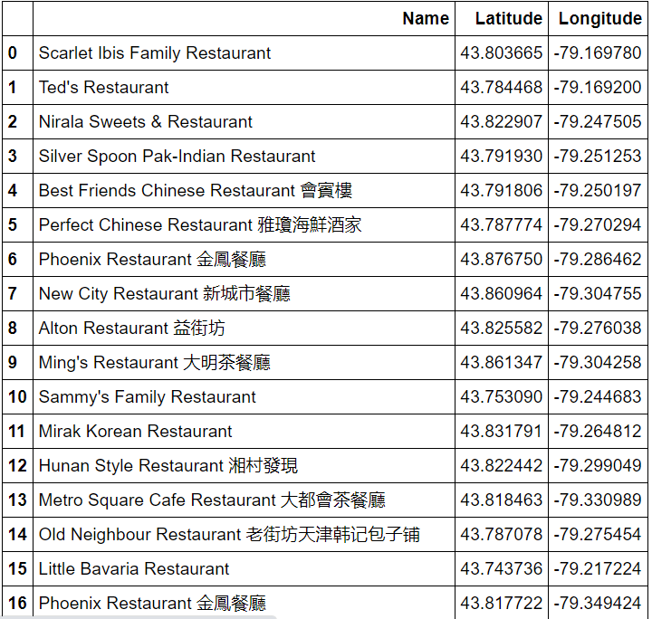

Data set of Bars

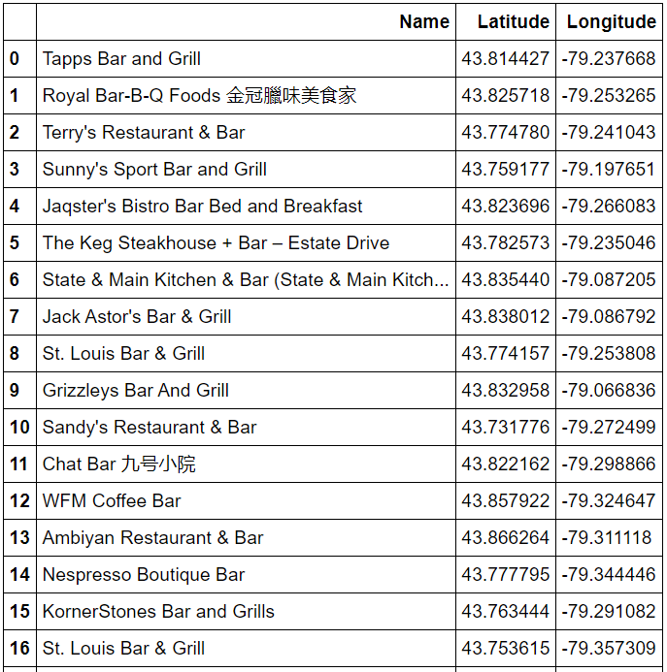

Data frame of Shopping Center

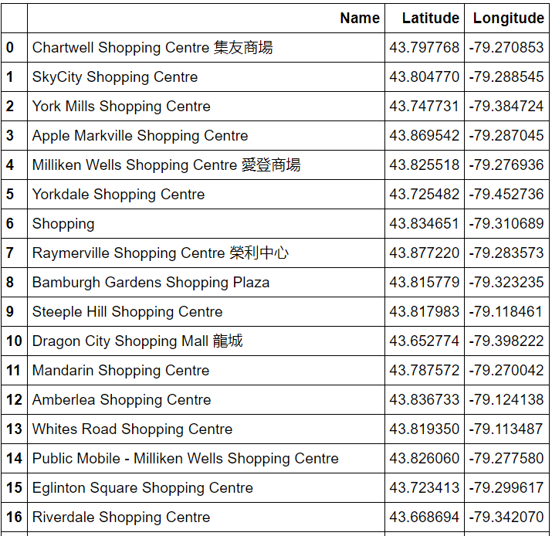

Data frame of Theaters

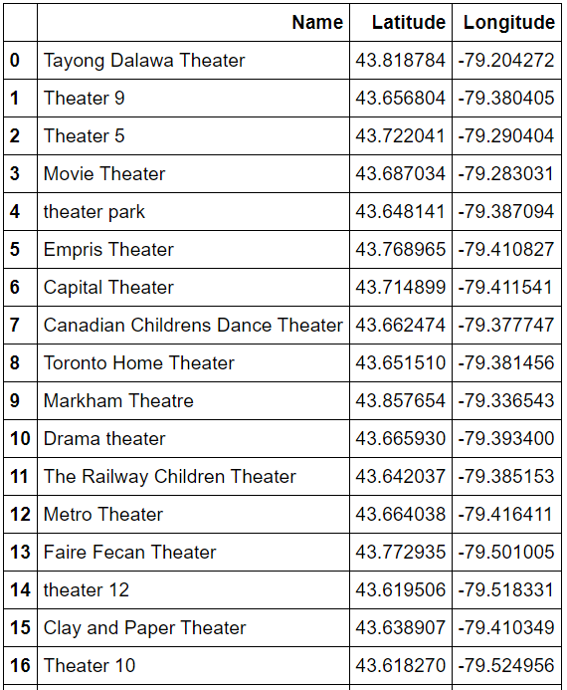

Using Folium we visualize that data in a map using marks and labels for the neighborhoods.

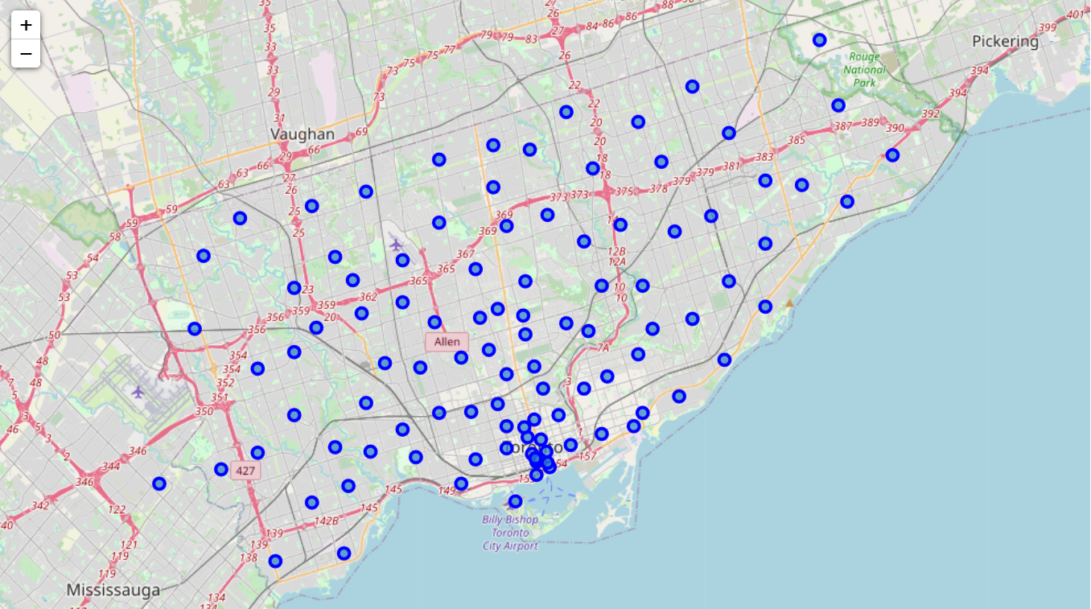

Now, using Folium, we will present the different categories of venues in the map of Toronto. We will use different colors for each category for better understanding.

* Black: Neighborhoods
* Red: Coffee Shops
* Yellow: Museums
* Green: Monuments
* Pink: Restaurants
* Orange: Bars
* Purple: Shopping Centers
* Blue: Theaters

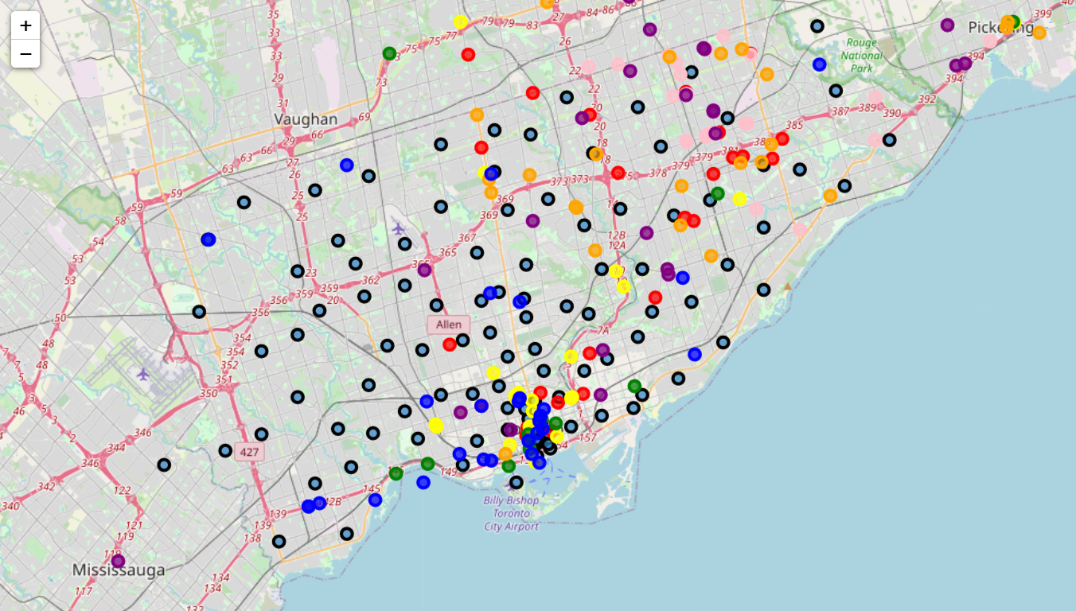

Zooming in the area that is obviously the one with the most bullets we can see clearly what’s around and according to our preferences we can choose the neighborhood in which we will look for a Hotel to stay in during our holidays in Toronto.

